linguistic and non-linguistic ways of revealing the meaning of unknown words in a foreign language classroom

A.A. Papoyan, Ph.D in Pedagogy, Associate Professor
Vanadzor State University, Republic of Armenia
annapapoyan@yandex.ru

Looking up each new word in a dictionary is one of the popular ways to deal with unknown lexical units, but sometimes applying a dictionary too much interferes with the comprehension process.
Thus, if the text comprises words that are new to the students, yet crucial for comprehension, there exist several strategies and steps to apply before looking up the word in the dictionary.
The paper emphasizes the importance of using these strategies and steps and suggests certain tasks to raise the efficiency of teaching new vocabulary.
Keywords: linguistic way; non-linguistic way; strategies; skills; word formation; word definition; vocabulary teaching

Teaching a foreign language is a complex process that often involves the risk of failure. We often find ourselves in a difficult situation when we try to introduce new vocabulary to a large number of students, who are not prepared for it. In such situations, a teacher has to decide whether he/she should follow the traditional “memorizing” principle or he/she should arrange interesting activities to help the students develop the skills to reveal the meaning of unknown words by themselves and easily assimilate new vocabulary.
Some of the reasons for failure while dealing with new vocabulary are connected with defective habits [3, p. 8-9]. Some of them are:
- One may confuse words that look similar, such as “quite” and “quiet”.
- While trying to guess the meaning of the whole sentence, one may consider each word by itself.
- One may “overuse” dictionaries by looking up every unknown word, etc.
A teacher, however, should create a motivating classroom environment, and should apply such activities (concerning the new lexical units), which as Collie and Slater [1, p. 8] suggest, “put fresh momentum by stimulating students’ desire to learn new words encouraging their responses”.
The article tries to highlight various interesting approaches towards the unknown lexical units, which may raise students’ comprehension level.
While working on new vocabulary items, the teacher should take into consideration the following scheme:

Scheme 1
Teach individual words

Vocabulary Enrichment
Teach word learning strategies
Provide rich and varied experience
Vocabulary Enrichment

As we can see in the scheme, all the mentioned units are interconnected and dependent on one another. They are considered to be keys to successful vocabulary teaching.
However, new vocabulary assimilation would be more effective if the students and the teacher take into consideration the following steps.
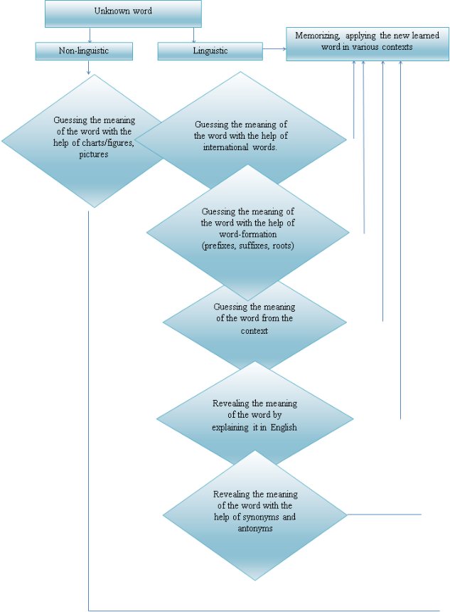
Anyway, we have worked out several activities according to the scheme above, which will help students improve their vocabulary according to various ways of revealing the meaning of unknown words.
- Group the underlined words in the sentences according to Brand’s table [2, p. 96].
- Have you heard anything about the Houses of parliament.
- Piccadilly Circus is bright in the daytime with flower-sellers.
- ...
Table 1
 | International words | Word structure | Guessing the meaning from the context | Proper names, Place names | Pictures to help to understand the words
- Houses of Parliament
- flower-seller
- ....
- Match the words and the suffixes.
-ity | -ment | -publish | -ness | -er
aesthetics | developed | espression | ism | agile
perform | al | architect | no suffix needed | ture
constract | tion | ance | calm | supple
- Express in one word.
- Abstract, classical, literary, realistic, romantic, renaissance - style
- Deep, flat, open, shallow - space
- Bright, cool, multicolored, pale, warm -
- Broken, horizontal, short, straight, thick, thin, vertical, interrupted -
- Chalk, pencil, ink, oil, watercolor -
  - Carving, ceramics, architecture, mosaics, sculpture, crafts, jewellery making -
- Find the word in the list according to its definition.
Asymmetrical | Architect | Photography
Applied art | Digital art | Mosaics
Cubism | Aesthetics | Facade
Advertising design | Canvas | Expressionism
Bleed Drawing | Quality | Abstract
Performance | Artists | Background
Art movement | Drawing | Sculpture
Gothic style | Constructions | Watercolor
Brush | Engraving | Ink
Aesthetics | Crafts | Publishing
an artist who plans and creates buildings. – Architect
an art movement that rejected recognizable subject matter and emphasized feelings and emotions. – Abstract
An area of graphic whose goal is to help inform, sell or promote products or services. – Advertising design
a branch of philosophy, concerned with the nature and value of art. -
Art made to be functional as well as visually pleasing. –
people who use imagination, creativity and skill to communicate ideas in visual forms.
A trend formed when a group of artists band together. –
The front of the building. –
Work of art which is made by cutting into a surface, inking the surface and pressing paper against it to make a print. –
- Choose the right word.
- mine, mire, might, mind
He doesn’t – his going there.
- sign, sink, sang, sing
My friend can not – at all.
- quiet, quite, quote, quit
My father is a – man, he doesn’t stand much noise.
- Write out the words, from the two sentences that have the same root and translate them into Russian.
- This is not a good company. It is not worth relying.
- My brother is a reliable person, he will do everything.

- I am not sure. The suggestion doesn’t seem sensible.
- My friends always feel hurt. They have no sense of humor.
- Underline the word closest in meaning to the first one.
- help – value, race, aid, advertisement
- some – proud, nice, several, good
- enough – sufficient, possible, understandable, fine
- funny – straight, easy, amusing, real
- Find the words that do not belong to the group.
clever
bright
beautiful
educated
thin
- Find the word combination, closest in meaning to the first one.
- a beautiful painting | - a beautiful place  - a beautiful picture  - a beautiful photograph
- a famous man | - a scientific man  - a nice man  - an outstanding man
- helpful suggestion | - valuable suggestion  - useless suggestion  - non-heard suggestion
- Find the word that is closest in meaning to the word in the left hand column.
- not usual | - else
- pleasant to eat | - risky
- showing good taste | - collect
- opinion about what to do | - tasteless
- free | - to my mind
- gather together | - tasty
- unpleasant to eat | - special
- I think | - spare
- besides, in addition | - tasteful
- dangerous | - advice
- Choose the right word that best completes each sentence.
- Bad luck is the only thing that can be achieved without - .
- effort b) pleasure c) strength d) money
- When they came home, he thought the children would be sleeping. But they were -.
- apart b) quiet c) awake d) friendly
- The morning passed quickly. When I looked at my watch I saw to my -, that it was nearly 8 o’clock.
- amazement b) cry c) shame d) belief
- Ann hurriedly opened the box and found it - .
- vacant b) real c) empty d) big
- Match the proverb with its paraphrase.
- If there is a result, there must be a reason for it. | - Actions speak louder than words.
- It is much more important what a person does, than what he says. | - A friend in need is a friend indeed.
- A true friend proves his friendship in hard times. | - When there is fire, there is smoke.
However, words, phrases, collocations are the tools which build up the language alongside with grammar. The teacher should try to find the best way to make the students learn as many words as it’s possible.

References

- Collie J., Slater S., Literature in the language classroom, Cambridge University Press, Cambridge, 1987, p. 8
- Sheils J. Communication in the Modern Languages Classroom, Council of Europe Press, 1993, p. 96
- Zhukova L. P., Reading and Comprehension, Vyssaja skola, Moscow, 1982, p. 8-9

